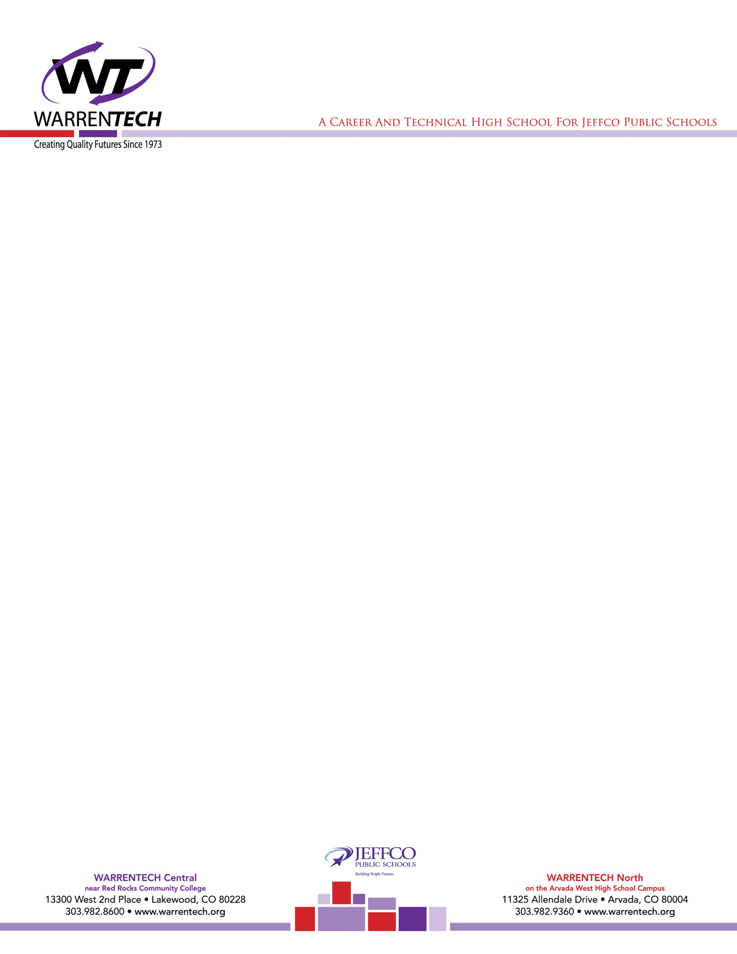

March 1, 2017

TO: NASA HUNCH Trip Students and Parents

FR: Joe Shaw, Principal, Warren Tech

Lisa Ritchie, Principal, Lakewood High School

SUBJECT: NASA HUNCH Trip Orientation Notification

Hello Students and Parents:

As part of the NASA HUNCH trip to Houston on April 17th – April 18th and April 19th – April 20th (we have two different groups going to Houston on separate dates) we will require all students and at least one parent/guardian to attend an orientation meeting on Wednesday, March 22 at 6:00 pm at the Warren Tech Central Campus in the Founders Room.

During the orientation we will review the travel itinerary, student expectations and review the travel and hotel arrangements. Additionally, we will have you complete the required district travel forms for students and provide parents with emergency contact information, etc. We will require students to bring a proof of health coverage that we will copy to have on hand while in Houston.

We are excited about this opportunity for your students as they have worked hard over the last two semesters to design and build their projects that have been selected for review by NASA. We look forward to a positive outcome for the students while they are in Houston. If you have any questions prior to March 22, please contact your students’ teacher.